Chapter 6, Problem 10.

The voltage across a 5-mF capacitor is shown in Fig. 6.47. Determine the current through the capacitor.

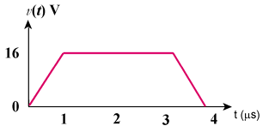
Figure 6.47
For Prob. 6.10.

